Operating Systems – Lab 10
Name: Hafsa Salman
Roll no. 22K-5161

Code Workouts (Lab Manual)

Code Workout 01
Code:
#include<stdio.h>
#include<stdlib.h>
#include<pthread.h>
#include<semaphore.h>
#include<unistd.h>

#define BUFFER_SIZE 5

sem_t mutex, empty, full;
int buffer[BUFFER_SIZE];
int in=0, out=0;

void *producer (void *arg)
{
int item;
while (1)
{
item = rand() % 100;
sem_wait(&empty);
sem_wait(&mutex);

buffer[in] = item;
printf("Produced: %d\n", item);
in = (in + 1) % BUFFER_SIZE;

sem_post(&mutex);
sem_post(&full);
sleep(rand() % 3);
}
}

void *consumer (void *arg)
{
int item;

while (1)
{
sem_wait(&full);
sem_wait(&mutex);

item = buffer[out];
printf("Consumed: %d\n", item);
out = (out + 1) % BUFFER_SIZE;

sem_post(&mutex);
sem_post(&empty);
sleep (rand() % 3);
}
}

int main()
{
pthread_t producer_thread, consumer_thread;

sem_init (&mutex, 0, 1);
sem_init (&empty, 0, BUFFER_SIZE);
sem_init (&full, 0, 0);

pthread_create (&producer_thread, NULL, producer, NULL);
pthread_create (&consumer_thread, NULL, consumer, NULL);

pthread_join (producer_thread, NULL);
pthread_join (consumer_thread, NULL);

sem_destroy(&mutex);
sem_destroy(&empty);
sem_destroy(&full);

return 0;
}

Part A:
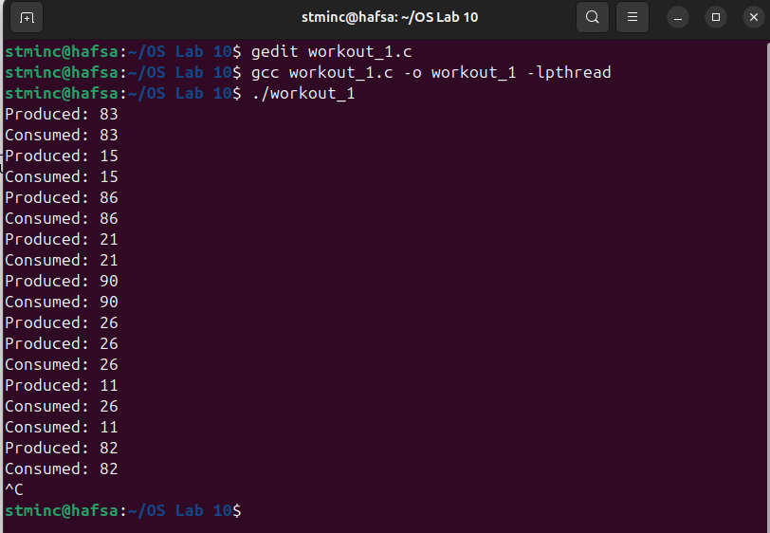

Part B:
Empty is being used by the producer to determine the empty indexes in the buffer.
Full is used by the consumer to determine the full indexes in the buffer for it to consume.

Part C:
Sleep() functionality is being used by the producer to impose that it is taking its time to produce an item and by the consumer to portray that it is taking to consume the item.

Code Workout 01
Code:
#include<stdio.h>
#include<stdlib.h>
#include<unistd.h>
#include<time.h>
#include<semaphore.h>
#include<pthread.h>

#define NUM_READERS 5
#define NUM_WRITERS 2
#define STRING_LENGTH 60

pthread_t readers[NUM_READERS], writers [NUM_WRITERS];
sem_t mutex, rw_mutex;
int readers_count = 0;
FILE *file;

char generateRandomChar()
{
return (char)('a' + rand() % 26);
}

void *reader(void *arg)
{
while (1)
{
sem_wait(&mutex);
readers_count++;

if (readers_count == 1)
{
sem_wait(&rw_mutex);
}

sem_post(&mutex);

fseek(file, 0, SEEK_SET);
char buffer[256];
while (fgets(buffer, sizeof(buffer), file) != NULL)
{
fprintf(stdout, "Reader %ld: %s", (long)arg, buffer);
}

sem_wait(&mutex);
readers_count--;

if (readers_count == 0)
{
sem_post(&rw_mutex);
}

sem_post(&mutex);

usleep(1000);
}
}

void *writer(void *arg)
{
while(1)
{
sem_wait(&rw_mutex);

srand(time(NULL));
char randomString[STRING_LENGTH + 1];
for (int i = 0; i < STRING_LENGTH; i++)
{
randomString[i] = generateRandomChar();
}

randomString[STRING_LENGTH] = '\0';

fseek(file, 0, SEEK_END);
fprintf(file, "%s\n",randomString);
fprintf(stdout, "Writer %ld: %s\n", (long)arg, randomString);
fflush(file);

sem_post(&rw_mutex);

usleep(1000);
}
}

int main()
{
file = fopen("shared_file.txt", "a+");
if (file == NULL)
{
perror("Error opening file");
exit(EXIT_FAILURE);
}

sem_init(&mutex, 0, 1); sem_init(&rw_mutex, 0, 1);

int i;

for (i = 0; i < NUM_WRITERS; i++) pthread_create(&writers[i], NULL, writer, (void *)(long)i);
for (i = 0; i < NUM_READERS; i++) pthread_create(&readers[i], NULL, reader, (void *)(long)i);
for (i = 0; i < NUM_READERS; i++) pthread_join(readers[i], NULL);
for (i = 0; i < NUM_WRITERS; i++) pthread_join(writers[i], NULL);

fprintf(stdout, "reader pthread join completed\n");

sem_destroy(&mutex);
sem_destroy(&rw_mutex);

fclose(file);

return 0;
}

Part A:
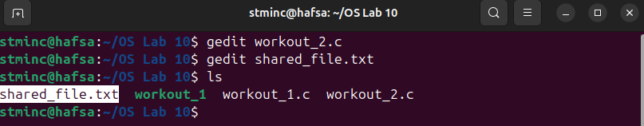
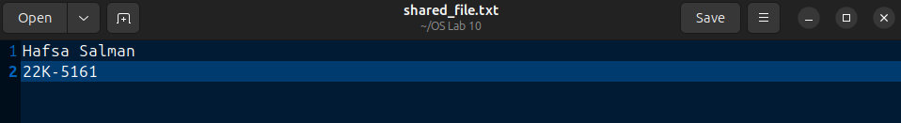

Part B:
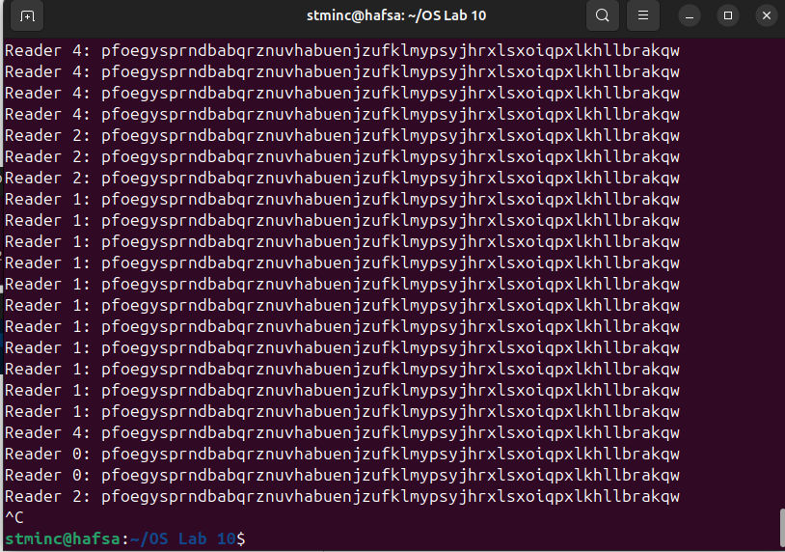

Part C:
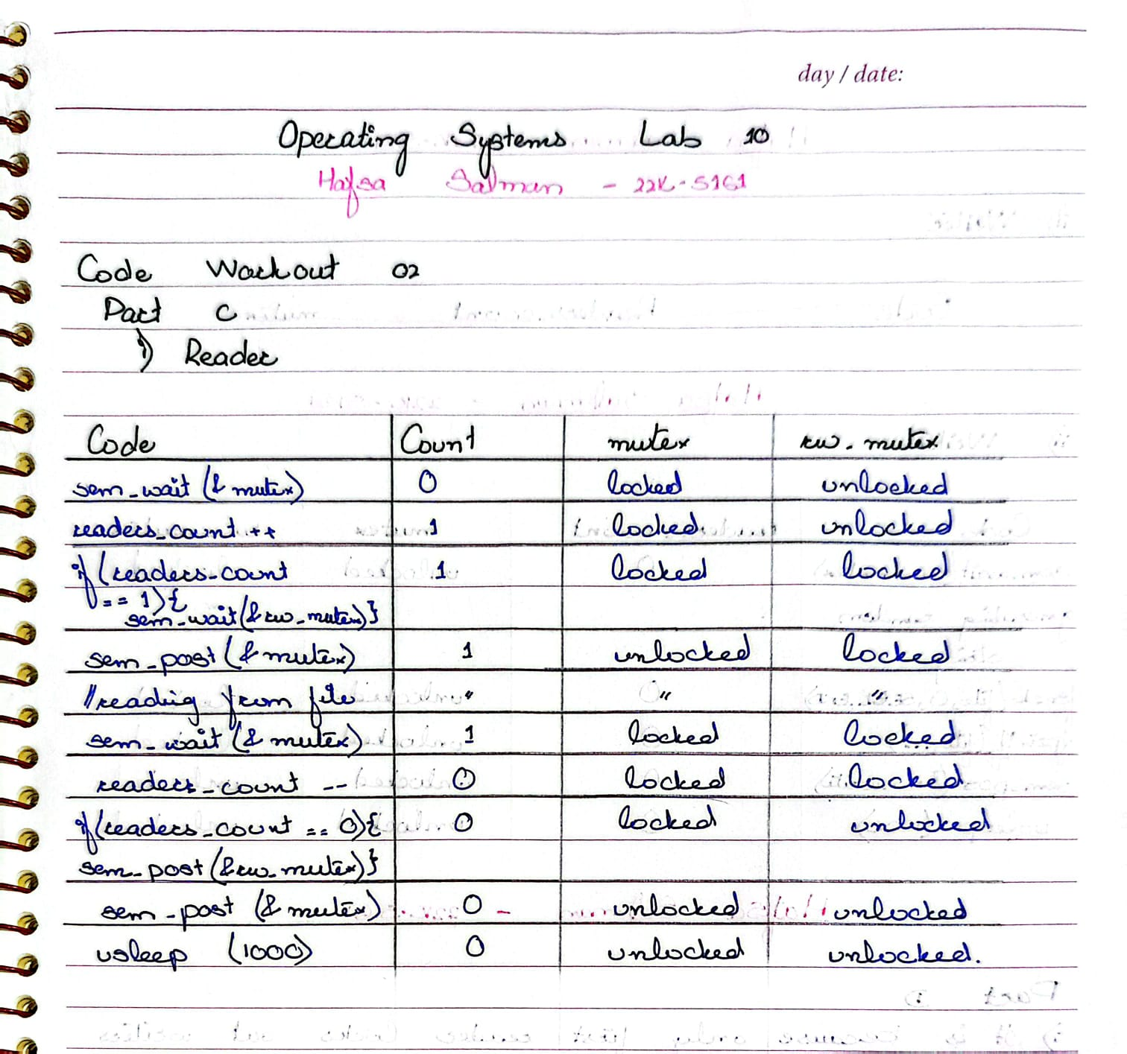
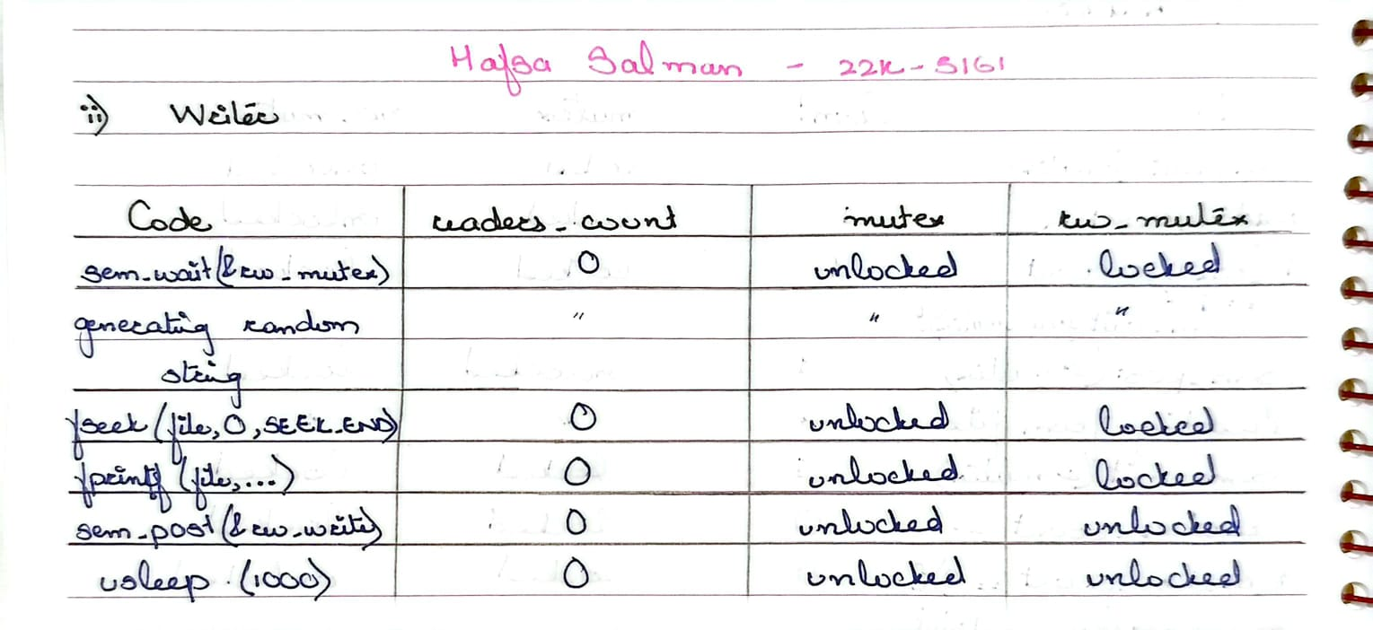

Part D:
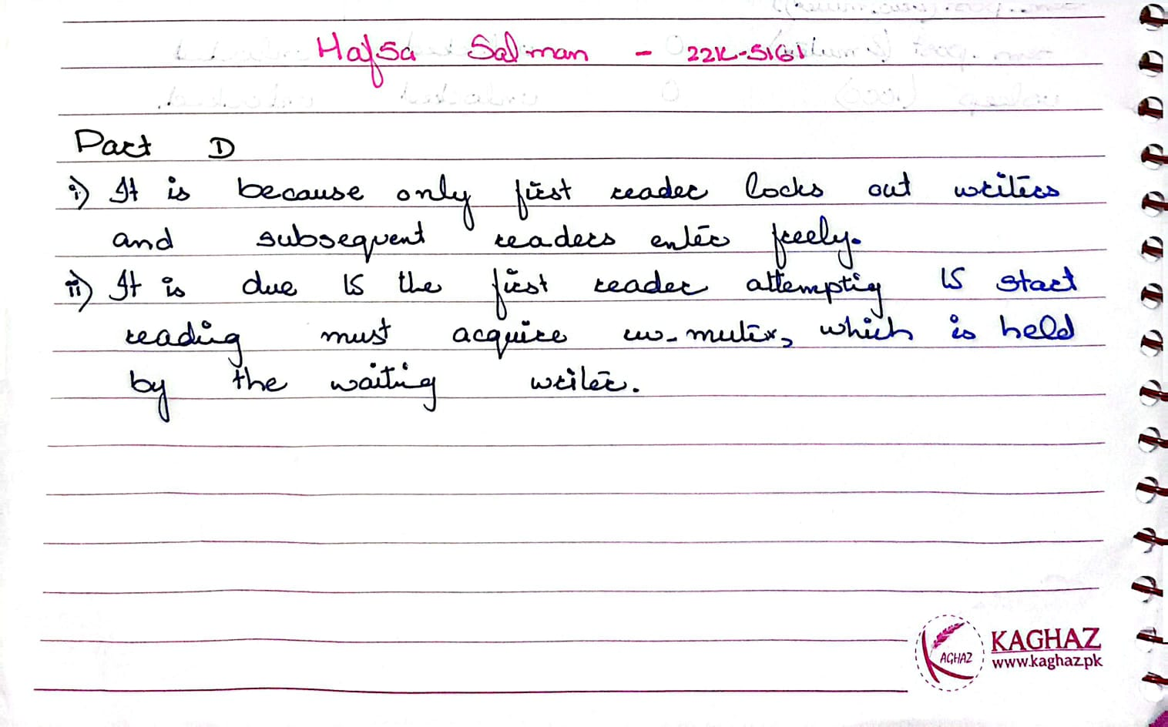

Part E:
Done as per the instructions and images are attached above.

Lab Tasks

Task no. 01: Part B
Code:
#include <stdio.h>
#include <stdlib.h>
#include <pthread.h>
#include <semaphore.h>
#include <unistd.h>

#define TOTAL_ICECREAMS 10
#define NUM_PERSONS 3

int remaining = TOTAL_ICECREAMS;
sem_t salesman_lock;

void* person(void* arg)
{
int id = (long)arg;

while (1)
{
sem_wait(&salesman_lock);

if (remaining > 0)
{
remaining--;
printf("Person %d took an ice-cream. Remaining: %d\n", id, remaining);
sem_post(&salesman_lock);
sleep(1);
}

else
{
sem_post(&salesman_lock);
break;
}
}

printf("Person %d leaves.\n", id);
return NULL;
}

int main()
{
pthread_t people[NUM_PERSONS];
sem_init(&salesman_lock, 0, 1);

for (long i = 0; i < NUM_PERSONS; i++)
{
pthread_create(&people[i], NULL, person, (void*)i);
}

for (int i = 0; i < NUM_PERSONS; i++)
{
pthread_join(people[i], NULL);
}

sem_destroy(&salesman_lock);

printf("All ice-creams finished.\n");

return 0;
}

Output:
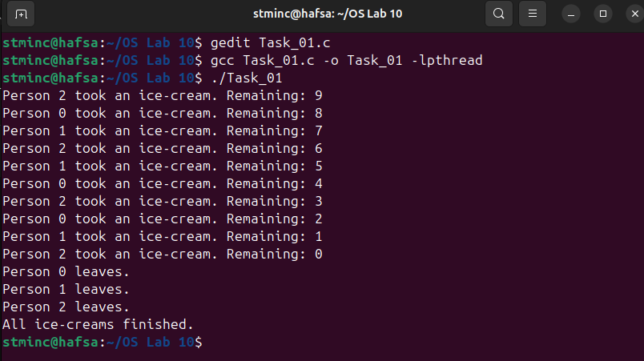

Task no. 01: Part B
Code:
#include <stdio.h>
#include <stdlib.h>
#include <pthread.h>
#include <semaphore.h>
#include <unistd.h>
#include <time.h>

#define TOTAL_ICECREAMS 10
#define NUM_PERSONS 3

int icecream_remaining = TOTAL_ICECREAMS;
sem_t salesman_lock;

void* person(void* arg)
{
int id = (long)arg;
srand(time(NULL) + id);

while (1)
{

sem_wait(&salesman_lock);

if (icecream_remaining > 0)
{
icecream_remaining--;
printf("Person %d got an ice-cream. Remaining: %d\n", id, icecream_remaining);
sem_post(&salesman_lock);
}

else
{
sem_post(&salesman_lock);
break;
}

int pay_time = 1 + rand() % 2;
printf("Person %d is counting money!\n", id, pay_time);
sleep(pay_time);

printf("Person %d paid for the ice-cream.\n", id);
}

printf("Person %d leaves.\n", id);

return NULL;
}

int main()
{
pthread_t people[NUM_PERSONS];
sem_init(&salesman_lock, 0, 1);

for (long i = 0; i < NUM_PERSONS; i++)
{
pthread_create(&people[i], NULL, person, (void*)i);
}

for (int i = 0; i < NUM_PERSONS; i++)
{
pthread_join(people[i], NULL);
}

sem_destroy(&salesman_lock);

printf("All ice-creams sold and paid.\n");

return 0;
}

Output:
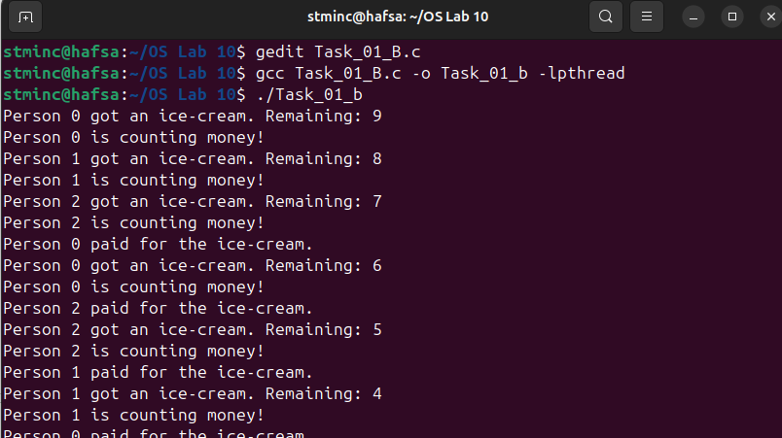
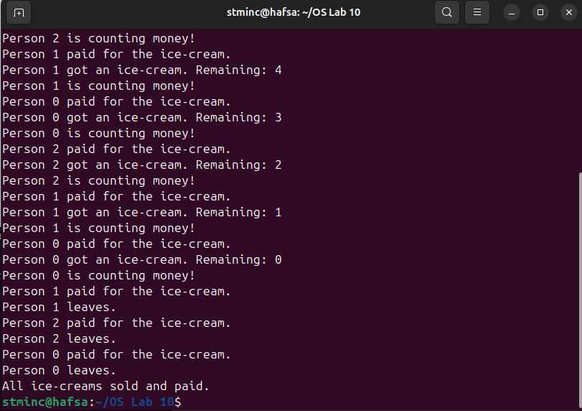

Task no. 02
Code:
#include <stdio.h>
#include <stdlib.h>
#include <pthread.h>
#include <unistd.h>
#include <semaphore.h>

#define NUM_CUSTOMERS 10

sem_t weigh_machine;
sem_t security_scanner;
sem_t boarding_counter;

void* customer(void* arg)
{
int id = (long)arg;

sem_wait(&weigh_machine);
printf("Customer %d is weighing luggage...\n", id);
sleep(4);
printf("Customer %d finished weighing luggage.\n", id);
sem_post(&weigh_machine);

sem_wait(&security_scanner);
printf("Customer %d is getting luggage security checked...\n", id);
sleep(7);
printf("Customer %d finished security check.\n", id);
sem_post(&security_scanner);

// --- Step 3: Boarding pass ---
sem_wait(&boarding_counter);
printf("Customer %d is getting boarding pass...\n", id);
sleep(3); // boarding pass takes 3 seconds
printf("Customer %d received boarding pass.\n", id);
sem_post(&boarding_counter);

printf("Customer %d has completed all steps.\n", id);
return NULL;
}

int main()
{
pthread_t customers[NUM_CUSTOMERS];

sem_init(&weigh_machine, 0, 1);
sem_init(&security_scanner, 0, 1);
sem_init(&boarding_counter, 0, 1);

for (long i = 0; i < NUM_CUSTOMERS; i++)
{
pthread_create(&customers[i], NULL, customer, (void*)i);
}

for (int i = 0; i < NUM_CUSTOMERS; i++)
{
pthread_join(customers[i], NULL);
}

sem_destroy(&weigh_machine);
sem_destroy(&security_scanner);
sem_destroy(&boarding_counter);

printf("All customers processed at the boarding lounge!\n");

return 0;
}

Output:
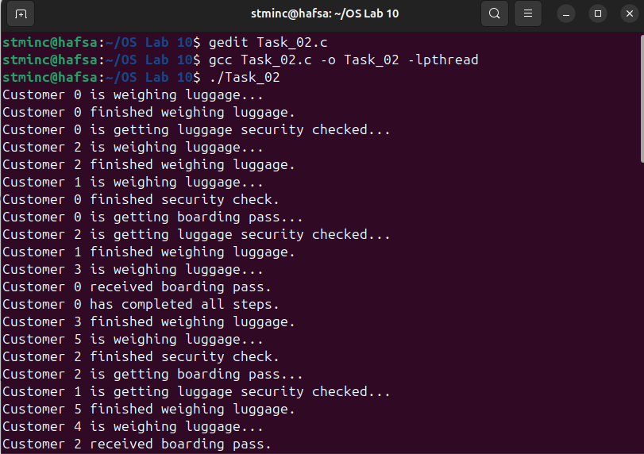
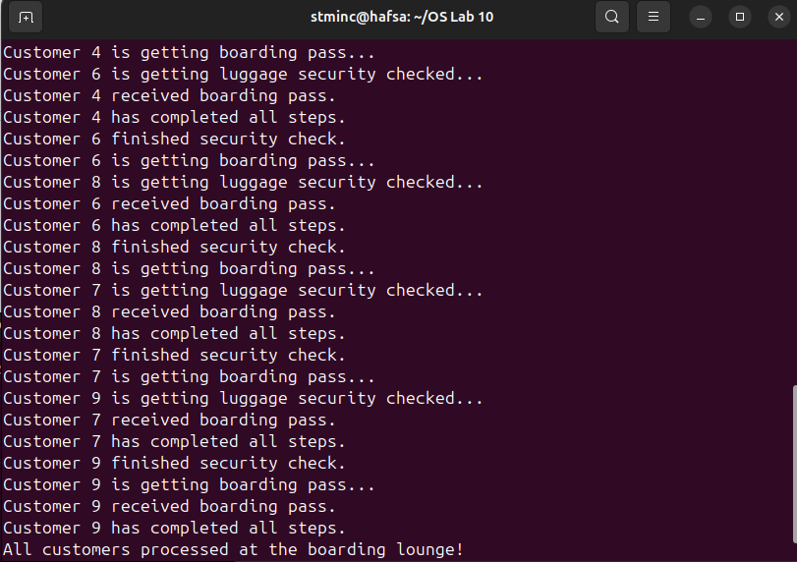

Task no. 03
Code:
#include <stdio.h>
#include <stdlib.h>
#include <pthread.h>
#include <unistd.h>
#include <semaphore.h>

#define TOTAL_TICKETS 20
#define NUM_SELLERS 4

int tickets_remaining = TOTAL_TICKETS;
sem_t ticket_lock;

void* seller(void* arg)
{
int id = (long)arg;

while (1)
{
sem_wait(&ticket_lock);

if (tickets_remaining > 0)
{
printf("Seller %d is selling ticket #%d\n", id, tickets_remaining);
tickets_remaining--;
sem_post(&ticket_lock);

usleep(200000);
}

else
{
sem_post(&ticket_lock);
printf("Seller %d: No tickets left.\n", id);
break;
}
}

return NULL;
}

int main()
{
pthread_t sellers[NUM_SELLERS];

sem_init(&ticket_lock, 0, 1);

for (long i = 0; i < NUM_SELLERS; i++)
{
pthread_create(&sellers[i], NULL, seller, (void*)i);
}

for (int i = 0; i < NUM_SELLERS; i++)
{
pthread_join(sellers[i], NULL);
}

sem_destroy(&ticket_lock);

printf("\nAll tickets sold. System shutting down.\n");
return 0;
}

Output:
